Code for Practical 3
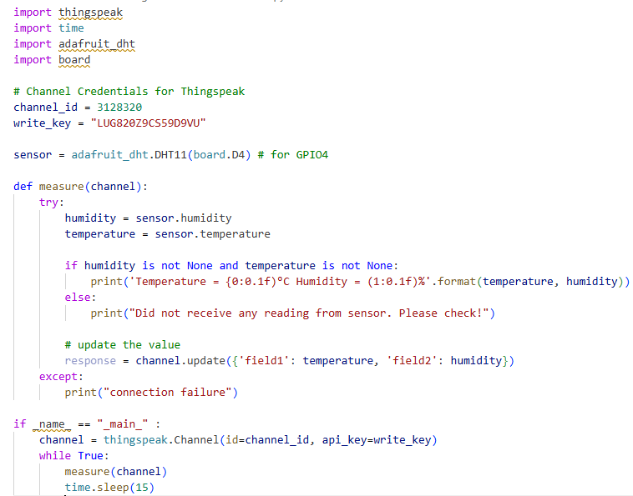

Output to Thingspeak.com
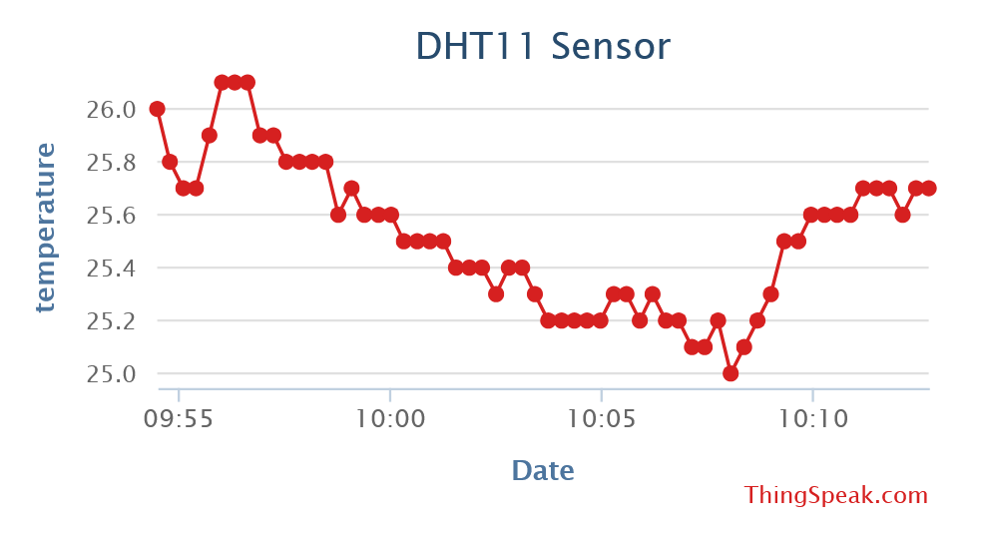
Figure 1: Temperature Graph
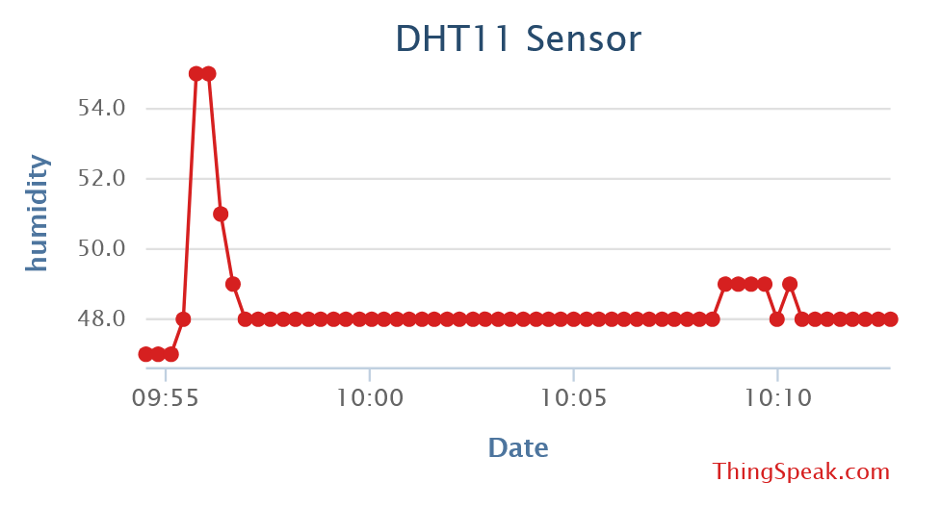
Figure 2: Humidity Graph

